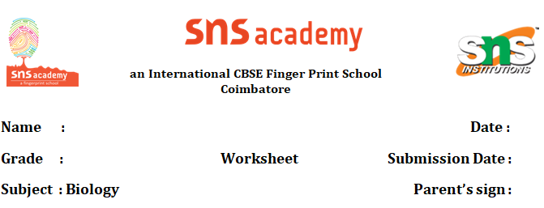

Garbage in and Garbage out - Puzzle

<https://quizizz.com/join/quiz/5efeed7f06cbef001b6e4c72/start?studentShare=true>

<https://quizizz.com/join/quiz/614d4bbe7f54a7001db87062/start?studentShare=true>